TV
[Company name] [Company address]
Case Study sample 1

The student’s name
University
Place
2nd October 2015

The president
US Department of Agriculture
1400 Independence Ave., S. W.
Washington, DC 20250

Dear Sir/Madam
Sub: Recommendation for Student Run farms

Improving diet and lifestyle is very important for the physical and mental health of citizens in a nation. Youth and children are optimal investments that can be made for the future of a country. They play a pivotal role in the nations development.
It is noticed that America now lacks a healthy lifestyle and are dependent on fast food restaurants, fast foods and processed foods for their day-to-day living. Schools are the immediate surroundings that influences convictions of a student and hence the importance of a healthy life style and organic farming should become a part of school curriculum.
A student run farm aligned to the school maximizes the physical, mental and emotional involvement of students in the crop cycle, that starts from preparation of the land, sowing, nurturing and harvesting. This will lead to healthy, wholesome, nutritious intake of food. Students will also learn to compare the health benefits of healthy nutritious food over fast and processed foods through regular farm visits.
Attached is a recommendation report for the alignment of student run farms with schools. I sincerely request you to take adequate actions required for the development of a healthy and energetic youth in the country.

Sincerely
NAME

Executive summary
Improved nutrition is the corner stone on which economies and modern societies can be built on. America now faces a problem from poor diets that are high in calories, sodium, and fats that simultaneously lack nutrition and have adverse impact on health. This is a recommendation report addressed to the School Authority, Educational Department and Department of Agriculture in USA. Recommendations in this report were formed through group discussion with peers and random data collection from teenagers and youth near fast food counters.
The problem addressed in this report is poor eating habits of youth and children in America and its impact on their health, performance and self-esteem. 63% of the calorie consumption of Americans is in the form of processed foods, 25% in the form of animal food and 12% in the form of plant food. The reasons behind this trend are explored to form a solution for achieving long-term benefits if implemented.
The recommendation consists aligning a farm to the school and making it a part of the school curriculum. The farm produce can be sold to students and families at a reduced rate and also be consumed in the school kitchen, which can produce savory items for student consumption. It also recommends frequent visits to organic farms that will increase their knowledge about the crop cycle. It stresses on the importance of nutrition atmosphere around students as they grow up and how important it is to include nutrition education as an important part of school curriculum.

Table of Contents
Executive summary 0
Introduction 4
Methodology 4
The problem study 5
Appealing nature of Junk food 5
Health impacts of Fast food 6
Issues with Processed Foods 7
Facts and Figures 7
Analysis and recommendation 9
Analysis of Reasons behind processed and fast food consumption 9
Options to make organic food more attractive 10
Recommended plans 10
Option 1: 10
Student Run Farm Plan 10
Option 2: 11
Organic projects and field visits 11
Farm to School Program 12
Objections and solutions 12
Conclusion 13
References 14

Introduction
Improved nutrition is the cornerstone upon which economies and modern societies can be built on. Adequate nutrition in the diet frees a nation and let its people pursue goals that improve human condition. America now faces problems of poor diets that are high in calories and fats and low in vegetables and fruits. The dietary problems faced by America today is poor eating habits, different from low calorie intake of the past, still takes a heavy toll on individuals and society.
The problem addressed in this report is unhealthy eating habits that are followed by the teenagers and youth in America unlike the recommended nutrition guidelines. There is a higher level of dependency on canned foods, fast food chains and junk foods as regular food. This is an unhealthy trend and leads to several disadvantages in the long run including becoming unhealthy, and reduced energy levels.
Changing food habits would require change in lifestyle, which should be inculcated in young citizens. To bring this change schools and universities would need to play an important role along with federal agencies like US department of education and US department of agriculture, US department of health. The major responsibility would be in the US department of education to inculcate a healthy lifestyle amongst the student community by making this part of the curriculum in schools and universities across the United States. Emphasis should be placed on turning the future generation away from the current food consumption habits and patterns.
The other governmental agencies like US department of agriculture would need to play a pivotal role in ensuring the student are exposed to the advantages of organic food by means of visits to leading nutrition institutes along with on field exposure to organic farming by inclusion of farms where sustainable organic farming is practiced. The health department also plays a vital role in spreading awareness about long term and short term impacts of the current leaning towards processed and junk food.

Methodology
This report is divided into three sections including the methodology, the problem study, the recommendation and conclusion. Peer-reviewed papers support theories presented in the report and data are supported by development organizations of US (national publications).
The sample population was chosen randomly from high school students frequenting the local fast food joints. The sample has been selected through analysis of the demographic group most at risk at being influence by advertisements and peer pressure into consumption of unhealthy food. Target audience behavior would be analyzed and studied through observations along with direct interaction with the target audience. A small group of 15 students were selected towards discussion, and their inputs were considered for further behavior study. These inputs also include the factor which made the target audience veer towards unhealthy foods rather than opt for healthy low calorie, and nutritious food. Various other impact factors like availability, taste, cost along with peer acceptance were also received as inputs for the study group
Details regarding their choice of food items and their frequency of visits to the fast food joint were analyzed along with the reasons of preference of high calorie junk food.
The target audience of this report is US Department of Education, US Department of Agriculture and Local School Boards who have the authority to make the required changes in policy making for schools and universities.

The problem study
The problem addressed in this report is poor eating habits of teenagers and youth in America and how fast food, dried foods and canned foods have influenced their food intakes. According to Vogli, Kouvonen and Gimeo (2014), there has been a substantial increase in mean body weight in wealthy countries. These changes are accompanied by changes in dietary patterns were there is a notable increase in the consumption of ultra-processed foods, including fast foods leads to a difference in the BMI.
The diet guideline recommended for Americans include a diet which is rich in fruits and vegetables, whole grains and as well as low-fat dairy products for people who are 2 years and older. The guidelines that are given for American also limit intake of solid fats (which is a major source for trans and saturated fatty acids), cholesterol, sodium, added sugars and refined grains (US Department of Agriculture, 2010). These recommendations are not followed by the youth of today. Irrespective of understanding the basic facts about nutrition and health principles people fail to follow through. In short the desire to have high-fat and high-sodium food outweighs their concerns about health and nutrition.
Following is a pie chart that represents US food consumption as a percentage of calories. In plant food even half it may be processed. Animal food serves as the primary source of saturated fat (USDA Economic Research Service, 2009)

Source: (USDA Economic Research Service, 2009)

Appealing nature of Junk food
Junk food is made up of things that and can be made quicker, tastier, convenient and fashionable. Following are some of the factors that make it more appealing (Ashakiran & Deepthi, 2012)
Time factor: Junk food is simple and easy to prepare and ready to consume.
Taste factor: junk food is tastier and this acts as a major reason for their preference over organic foods. This is because of the usage of oils, salts and sugar.
Attractiveness: junk foods look very attractive because of the packing, addition of food additives and artificial colors along with flavor.
Ad factor: advertising has a major influence on the food selling joints and hence youth are attracted to most advertising brands.

Health impacts of Fast food
Due to the wide variety of choices, when it comes to dietary options involving high calorie and junk food, youth are drawn towards it. When you combine targeted marketing by fast food MNC’s combined with attractive pricing, convenience and taste associated with over the shelf fast food, it becomes difficult for the youth to choose alternative, wholesome, nutritious food which at times is more expensive, inconvenient to prepare, and tastes less than comparable fast food products. It becomes all the more imperative to ensure that policies are framed to promote wholesome, nutritious, organic food products.
High levels of sugar and calories are noteworthy as a substance, because it releases opioids and dopamine when digested at large quantities and thus have an addictive potential. When carried test in rats for components of addiction like bingeing, withdrawal, and craving and cross sensitization, it was proved that they became sugar dependent (Avena et.al, 2009)
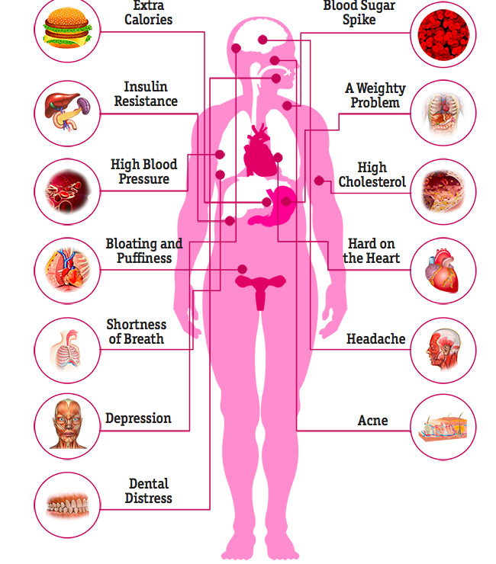
Source: (Healthline, 2015)

Fast food being processes contains large amount of carbohydrates, added sugar, unhealthy facts and salt. These foods contain very high calories, but little nutrition value. How ever, these foods impact health in a variety of ways and also result in chronic health problems. Some impacts of fast food are as follows (Healthline, 2015)
Digestive and cardiovascular systems: high level of sugar and carb intakes leads to a spike in the blood sugar level impacting insulin response. This leads to a high risk of developing and type 2diabetes. Fast food is known to raise LDL level of cholesterol and sodium content in fast food retains water. Cholesterol and salt will setoff blood pressure, heart diseases and stroke in a chain (Ashakiran & Deepthi, 2012).
Respiratory System: People who consume fast food are at the risk of respiratory problems.
Central Nervous System: Some triggers for headache occurs due to the intake of salt, processed meats, nitrates and MSG.
Skin and bones: carbohydrates increase blood sugar level and trigger acne. Sodium can induce osteoporosis.

Issues with Processed Foods
Canned goods remain an option if fruits and vegetables when vegetables are out of season. It is usually cheaper when fruits are canned (Dray, 2014)
High in sodium: There is high content of salt in canned foods. Salt helps in preservation of food. The content of sodium is not always evident on labels. But it leads to water retention and increase in calcium loss.
High in sugar: Canned fruits usually contain high levels of sugar. This sugar content makes the fruits more like deserts and tastier. But unfortunately it also increases the level of sugar and carbohydrates intake when the product is consumed.
Fewer nutrients: the peels are usually removed when fruits are canned and so it reduces the fiber content of the fruits. The cooling and canning process of the fruits and vegetables usually destroys its vitamin c content. There is also a lack of variety when it comes to canned foods.
BPA content: The canned foods tend to have plastic coating inside the can to keep them fresh. FDA convinces us that small amounts of it should not worry the users, but the fact remains that small amounts or not crude oil is not to be consumed.

Facts and Figures
It is highly necessary to look at the facts and figures to understand the alarming food issues in USA. There are both immediate and long-term effects on health and well-being of youth when they are obese.
The immediate health effects are that they are likely to have cardiovascular disease like high blood pressure and high cholesterol. Seventy percentages of the youth have had at least one risk factor for cardiovascular diseases. They are more at risk to have bone and joint problems, sleep apnea and social and psychological problems like poor self-esteem and stigmatization. The chances are high for them to develop cancer in the long term (CDC, 2015). According to Kff (2011), the percent of overweight or obese children in United States is 31.3%.

The following graph depicts high school obesity by state in US, 2013.
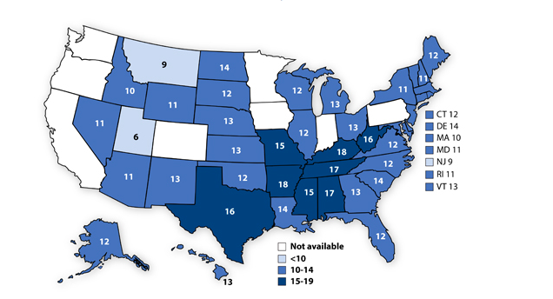
Source: (CDC, 2014)
It can also be seen that people are eating more processed food that ever. The following graph depicts Where Americans Eat (1889-2009).
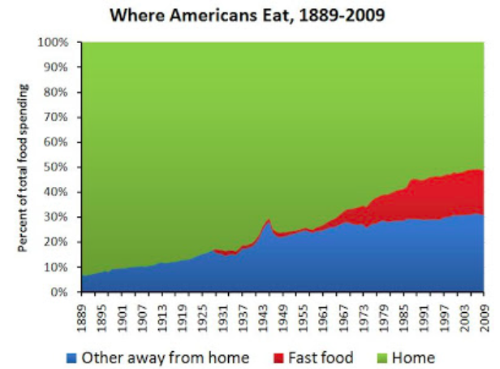
Source: (Guyenet, 2011)
In the graph it can be seen that 93% of the food consumed were from home in 1889. But in 2009, barely half (51%) is consumed at home, of which a high proportion is processed food.
Almost 90% of an average family’s grocery budget is spent is spent on processed foods according to Healthy Child Healthy World. Forming a diet that has high processed foods has the potential to lower the IQ of children according to Avon longitudinal study of parents and children by university of Bristol (Sutton, n.d). Research has also shown that food additives that are used in food can cause temper tantrums and disruptive behavior in children (Utton, 2011).
Apart from all these, the chances are also high for this diet to weaken immunity in a children and youth. Western diet now has issues with overconsumption of sugars, fat, salts and other additives that usually protects from nutrient deficiencies, leads to inflammation, reduced control of infection, increased rates of cancers and risk for allergic as well as auto-inflammatory diseases (Myles, 2014).
One in three students of US is obese and is under the threat of long term and short term health problems. Their contribution towards the country can also be highly impacted because of the health problems, low self esteem, lower energy levels.

Analysis and recommendation
Resolving the situation in US requires a lifestyle revolution where there is improved access to healthy food. Resolving a situation like this requires policy reformation, and responsible involvement of various departments including health, development, and education to change perspectives and way of life from the young age.
Schools can be considered to be in a unique position when it comes to its capability of promoting healthy eating habits and ensuring that food and nutrient intake is appropriate in students. Schools nurture students and
This can be made possible by giving students an array of opportunities to have healthy beverages. Schools should make sure that only nutritious and appealing foods and beverages are given in cafeterias, snack bars, school stores, and vending machines.

Analysis of Reasons behind processed and fast food consumption
These are the major analysis derived from the group discussion and data collection.
Convenience: the fast food joint being near to school makes it highly convenient to order or take away or grab a bite while going home. Less preparation time means less waiting for students and all of this makes it a highly convenient option rather than going in for other options which is usually time consuming and expensive. Processed foods are highly convenient because in most cases they can be directly used in the dishes to be assembled.
Also, waste created by canned foods is minimal in comparison to the waste created by fresh fruits and vegetables. Canned foods only have to be opened and fruits and vegetables have to be washed, cleaned, peeled and diced for consumption. The requirement of immense patience and basic kitchen skills is demotivating to teenagers and youths. The perishability of fruits and vegetables are also a reason why they prefer processed food. This also means lesser number of visits to grocery stores, which is convenient for parents and caretakers who are working in different shifts.
Price: Most fast food chain food comes cheap in comparison to theme-based restaurants. Youth usually do not have the budget to go to a theme-based restaurant. So is the case of purchasing fruits and vegetables if they are not in season. Processed foods are cheaper in comparison to fresh fruits and can be handled easily.
Packaging and appeal of advertisements: packaging and appeal of advertisements are very high for students. Youth connects with the advertisements of fast food chains and hence the responses are very high to such advertisements. There are few advertisements, which urge the youth to grab a fruit and chill.
Taste: The added sugar, sauces, sausage, patty and fat content add on to the taste of pre-processed food and fast foods. Youth you have it experiences a fulfillment while having fast food, which cannot be compared to the natural raw, taste of fruits and vegetables. Also, fast foods are filling and lasts you for a very long time, unlike salads that make you hungry in a few hours time. They also claimed that fruits and vegetables almost taste the same unlike burgers that taste different. The availability of options in fast food that are equally tasty is yet another advantage of fast foods.

Options to make organic food more attractive
Some of the suggestions that came up in the discussion were that
Easy availability: If there was a way in which fresh cooked foods were easily available on time, with out increased expenses, they were ready to consume.
Lack of desirability: according to the discussion vegetables and fruits failed to produce desirability in youngsters, irrespective of knowing its advantages. No advertisements are made to increase its desirability and hence it is not appealing.
Lack of knowledge: children in most cases are attracted towards fast food because of their lack of knowledge. They are also naïve to understand the intentions behind advertisements that are all over billboards and hoardings, in television and other media.
Lack of connection: along with the inconvenience of sourcing organic food, youth do not feel any emotional attachment to them. This is mainly because of the lifestyle in which they spend majority time on electronic devices and social media. The concepts of intangible potential wealth creation means have taken youth from the pleasures of small things like tangible creativity and gardening. So reintroducing the importance of playing and working on land is important to save humanity from the hand of readily available facilities.

Recommended plans
The school nutrition environment should not only allow students to practice healthy eating, but also offer different opportunities to learn

Option 1:
One of the options that universities can adapt is to align small farms to universities and schools were students would be able to observe the crop cycle. This would ensure students understand concepts of farming along with importance of organic food crops, which offer high nutritional value. The best way would be for universities to run these farms with student assistance in the form of farm project, which would be a part of the curriculum.

Student Run Farm Plan
The US department of education can join hands with US department of education to align farm space to the schools and universities with in US. It is advisable to undertake a small area of land and run the primary test for its success. Volunteers can be chosen from teachers and students to conduct farming operations. Seeds and plants can be planted with the help of automated planters that can be sourced from the major farms in the area as a part of justifiable social cause. In case the student body is unable to obtain these planters, groups of students can be allotted these tasks on a rotational basis. This would also ensure that the students are aware of the different methods used from sowing till final harvesting of these crops.
The best ways to market the produce would be to parents, friends and relatives of the local students who can order a weekly box of organic vegetables, which will be delivered to their homes. Teachers can also volunteer to make sure that the project becomes financially sustainable. Anything that is not available can be sourced externally by trading surplus vegetables produced at the form. However, the main motive behind the student run farm should be self-sustenance when it comes to finance.
The major intention being that the food grown is free from pesticides and conventional fertilizers, many different methods can be adopted for controlling weeds, increasing productivity and controlling pests. Control methods like plastic mats, burning of weeds, and hand picking can be adopted in addition to usage of beneficial insects and companion plants for pest control. Manual intervention for weed and pest control can be done using selected group of students who would be specifically educated on how to conduct these activities.
Students themselves can do harvesting of the vegetables. Once the fruits are ready, they can be harvested, sorted and boxed for buyers. In addition to supplying organic vegetable in cartons to families, it can also be used in the school cafeterias. There can also be a communal kitchen, which will serve dishes of these organic vegetables so as to promote usage and take a load of the financial cost.
Justification: This will enable the students to gain first hand knowledge of organic foods and the high nutritional value they offer. The student community along with the families would offer a steady market for the produce from these farms. This in turn will ensure that good quality organic food materials are available which offers high nutritional value and health benefits. Student’s activities and conception of food is very much influenced by the nutrition environment around them. Crops will be easily available when distributed from school, cheaper prices. Making sure that savory dishes are cooked with these crops is consumed by the students, will gradually help them to understand and compare quality between processed food and fresh food. Consuming fresh fruits and vegetables when induced in students, as a habit will ensure that they keep up these it as they become older. When children are acquainted to the crop cycle and get in to ease of farming from after the initial inertia, chances are high for them to motivate their family members to have a kitchen garden. Also, student run farms require physical activity, which is something the current generation lacks. Eventually, it may help to divert attention of students from electronic items to nature. It will also help in opening farming as a carrier option for students, which is quite uncommon now. This recommendation has a high potential not only for obtaining nutrition, but also to tackle issues in relation a younger generation who conveniently tends to overlook the importance of nurturing environment.

Option 2:

Organic projects and field visits
If a university aligned farm project is not feasible, the next option to be explored would be a study visit near by farms were organic farming methodology is used. Such visits will expose student to the benefits of having high nutritional food products as a part of their diet when they realize the nutritional value of these product along with the associated health benefits.
Frequent visits helps children to apply skills on the basis of their knowledge. It is important to access a farm that willingly accepts participation of students in their performance. With the willingness of the farmer, student participation can be ensured in crop cycle. The effectiveness of this option is dependent on the frequency of trips made to the farm and the number of students taken in a batch. But depending on the nature of the farm, the crops will differ. And hence the activities that can be arranged in relation to the farm visits are dependent on the nature of the farms. It will also help in opening up organic farming as a career option for students. Trips should be planned in advance for the kind of activities that can be conducted. But it will be optimal to select farms that engage in crop rotation. But long term, this can prove expensive for the school, as it may not provide the same benefits as having a farm associated to the school. Schools also have the option of partnering with community farm. Every week an allotted batch can work in the community thereby improving their social skills, commitment and knowledge about farming.
Justification: According to Charles Jordan, “what people do not understand, they do not value; what they do not value, they will not protect, and what they do not protect, they will lose”. Children have little of no knowledge about farming. Visiting farms will act as a tangible way to reconnect youth with agriculture. It will also inspire them to make healthier food choices to a certain limit. It will also enhance the value of farming and understand the cycle that happens from turning a seed to dish on table. The visits should not restricted one time a year, but more than that to understand various cycles. This will not only be an inspiration for the students, but will also help the farm to earn that extra cost required to meet that additional expenses. Farm visits are not always about vegetables and fruits, but also animal welfare projects, where students experience first hand about how important it is source meat from ethical and organic farms. Farm visits are usually a part of the school curriculum now. But it is important to make sure that farms visits are not taken as a fun trip for children and ensure that the visit creates value for them.

Farm to School Program
USDA has launched a farm to School program that will assist the eligible entities to implement school programs that will improve the access to local food in schools that are eligible. There are four types of grants that are available from USDA. They are support service grants, implementation grants, planning grants and training grants. The school must apply for getting grants and its eligibility. Though full funding to this program is not available, USDA is supportive in such venture and their assistance will make sure that the farm project is successful. Among the different grants that are available, planning grants are the most suitable one for schools who are getting started on farms in schools. It is for helping schools to organize and structure their efforts for getting a maximum impact from embedding known best practices (USDA, 2015).

Objections and solutions
There are many students run farms in America.
Financial constraints: there is possibility that lack of funds will lead to ineffective implementation of the program. So to ensure that the program is not effected by financial constrains, buying will be required from all stakeholders to ensure success of the program. Previous performance when it comes to implementation strategy will also play and major factor in investors deciding to agree for the implementation of this program.
Lack of cooperation: In case of lack of support from federal agencies like US department of agriculture and education, the project can still be funded from the local bodies budget and it would not cost any external agencies to get the required funding.
Aligning this field project to their grades can curb lack of interests from the student body. Additional points could be awarded to students displaying leadership, multitasking, offering additional inputs and assistance along with bringing in improved sales.
Lack of interest from the school management can be addressed by conveying the importance of this project, especially when it comes to the long-term health benefits of the student population.
Lack of cooperation from parents: A meeting can be convened to inform the parents about the statistics on health issues caused by dietary habits. Along with this a full-fledged explanation or presentation of the farms, the activities carried out and the assistance provided to the farmers by the students can be notified. This would ensure that parents are also connected to he project and hold their wards responsible for completion.
Issues in adding this project as a part of school curriculum: the school boards should be notified about the advantages of running this farm along with the latest spin offs on health and productivity. School board should be made aware of the operational idea behind the farm, which is to generate awareness amongst the students about healthy, wholesome nutritious food and how it reaches the table. In addition to this they should be given an explanation about the business model being followed to ensure sustained profitability.

Conclusion
The major recommendation in this paper is to bring a system where organic farming is a part of the school curriculums and university education. The first hand experience with organic farming will inspire students to adapt a healthier living style. The US department of agriculture should join hands with US department of education to include basic steps of organic farming as a part of curriculum. This will further enhance their knowledge in advantages of having high nutrition based organic fruits and vegetables in comparison to the disadvantages of having food infused with trans-fat, sugars, sodium, and other artificial emulsifiers.

This recommendation when implemented will act as an integral initiative towards inducing healthy food habits in children and youth of the country. Actions and precautions that are taken by the government along with a step like this helps in reducing intake of canned foods, junk foods, fast foods as well as other issues that are found in the younger generation to a great extent. In short this is a recommendation for including nutrition education as an integral part of school health curriculum through various measures.

References

- Ashakiran & Deepthi, R., 2012, Fast foods and their impact on health, JKIMSU, 1(2), 7-15.
- Avena, N. M., 2013, Evidence for sugar addiction: behavioral and neurochemical effects of intermittent, excessive sugar intake, Neurosci Biobehav Rev, 32(1), 20-39.
- CDC, 2014, Obese Youth Overtime. Available from http://www.cdc.gov/healthyschools/obesity/obesity-youth.htm.
- CDC. 2015, Child obesity facts. Available from http://www.cdc.gov/healthyschools/obesity/facts.htm.
- Centers for disease control and prevention. (2014). Youth Risk Behavior Surveillance. Morbidity and mortality weekly report, 63 (SS 4): pp. 1-168.
- Dray, T., 2014, The disadvantages of canned foods, Available from http://www.livestrong.com/article/465106-the-disadvantages-of-canned-foods/.
- Guyenet, S., 2011, fast Food, Weight Gain and Insulin Resistance. Available from http://wholehealthsource.blogspot.in/2011/05/fast-food-weight-gain-and-insulin.html.
- Myles, I. A., 2014, fast food fever: reviewing the impacts of the western diet on immunity, Myles Nutrition Journal 2014, 13 (61), 1-17.
- Sutton, A. (n.d). Can Eating processed foods have a negative impact on a child. Available from http://everydaylife.globalpost.com/can-eating-processed-foods-negative-impact-child-30941.html.
- US department of agriculture, 2010, Dietary guidelines for Americans, Available from http://health.gov/DietaryGuidelines/.
- USDA Economic Research Service. (2009). US food consumption as a % of calories. Available from http://www.nyu.edu/sustainability/pdf/NYCHSF_FoodGraph2.pdf.
- USDA, 2015, Farm to School Grant Program. Available from http://www.fns.usda.gov/farmtoschool/farm-school-grant-program.
- Utton, T., 2011, which food additives make children behave badly, Available at http://foodmatters.tv/articles-1/which-food-additives-make-children-behave-badly.

