TV
Microsoft [Company address]
Economics Sample 1

Question 1
The rationale behind carbon tax is to reduce CO2 emissions to the atmosphere. Larger amount of carbon dioxide has destabilized the climatic patterns and also have threatened the ecosystems of earth. There is a requirement to reduce the carbon dioxide emissions for the purpose of avoiding climate change, spread of diseases, agricultural failure and water supply. Taxing is the one of the few steps that can be taken for reducing the carbon dioxide emissions (Carbontax.org, 2013). This will also act as incentive to establish technologies and consider carbon emission as a factor while major decisions are made by organisations and countries. Population will have to bare the carbon tax for elastic and inelastic goods and services.
Carbon Tax
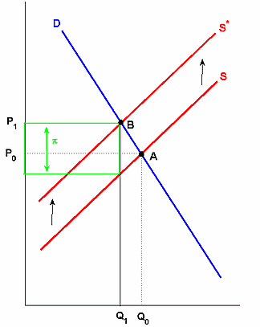
Source: (economistview, 2008)
In the case of carbon tax the price increase will be lesser than tax. But the chance is that the increase in price will be close to π.
Emissions trading
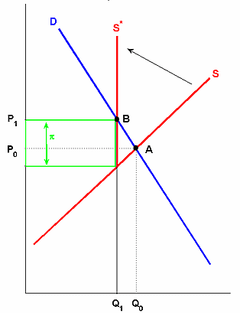
Source: (economistview, 2008)
The price changes in the case of emissions trading are also equivalent. But the difference is on terms of what happens to the profit.
Carbon tax VS. Emissions trading
In the case of carbon tax, government sets the price for carbon and the resulting market forces are responsible for determination for quantity of the emissions that should be reduced. This means that there will be certainty about emissions where business is concerned and the resultant emissions may vary. There are higher chances for a negative impact when it comes to growth and income. This will increase government revenue and it can be used for compensation.
In the case of emissions tax, the government will cap total amount of emission and permits will be issues. The market will be allowed to determine carbon price and hence prices can be fluctuating and volatile. There is also a limit on the level of emissions (ABC News 2011).

Question 2
Work choices vs. Fair Work
One of the main reasons for the unpopularity of the work choice was loss of unfair dismissal laws. The power of trade unions were diminished as they considered it to have too much of influence. Employees were given less power of bargaining when it was concerned with pay, hours and dismissal. It was thought to be unfair to workers. This gave lesser power to the employees and they were sacked unfairly with no provisions to seek legal help. The liberal party was anti work union and hence trade unions were not at all appreciated.
Fair Work Act brought about a positive change to the employees as they re-introduced unfair dismissal laws and the new enterprise bargaining rules. But the main disadvantage is that there is confusion about the laws influence on business and workers. This was a complete change to the industrial system and because of that there was a delay in catching up with the recent progress. Implementation and success of this law would be time and energy consuming. There are chances for employees to claim their right for unfair dismissal now, but many employees are bound to ignore the deadline as time allow ant time gap between lodging a complaint is 14 days in case of unfair dismissal. It is also said that there is too much of regulation including more power in the hands of the employees. So the chances are that the employees will employ less number of employees.

Carbon Tax. (2013). Whats a Carbon tax. Retrieved from http://www.carbontax.org/introduction/.

ABC News. (2011). Explained: Carbon taxes, emissions trading and direct action. Available from http://www.abc.net.au/news/2011-07-07/explained-carbon-taxes-emissions-trading-and/2785736.
Economist view. (2008). Carbon Taxes vs. Cap and Trade. Available from http://economistsview.typepad.com/economistsview/2008/06/carbon-taxes-vs.html.
Stacklaw. (n.d). Work Choices vs. Fair Work. (n.d). Available from http://www.stacklaw.com.au/templates/stacks/media_releases/090924_WORK_CHOICES_VERSUS_FAIR_WORK.pdf

